Sri Lanka Institute of Information

Technology



Lab Submission

Lab sheet No 9

**IT24101681**

**Senanayaka S.A.A.T.C.**

**Probability and Statistics - IT2120**

B.Sc. (Hons) in Information Technology

Exercise

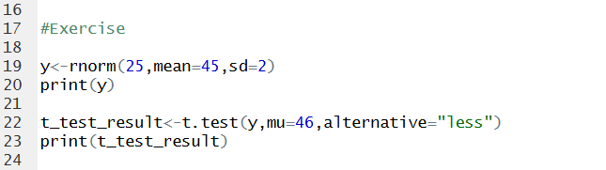

Output



